Schematic Diagram for Operating Point: -

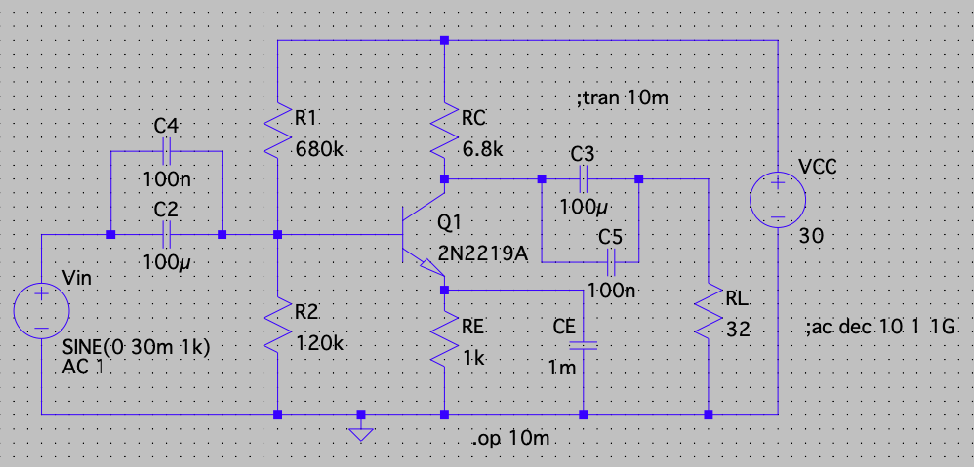

Output: - (Operating Points)

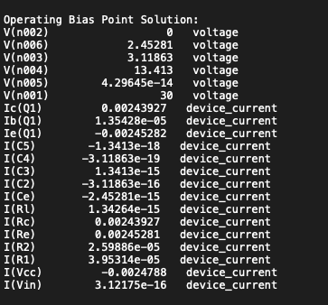

To find the frequency response, maximum gain in Db and phase difference: -

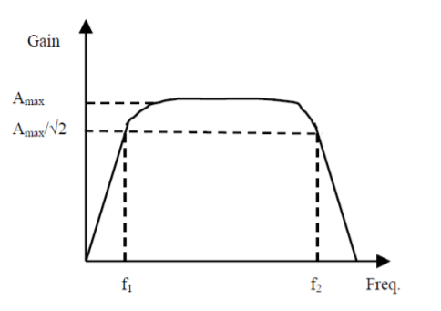

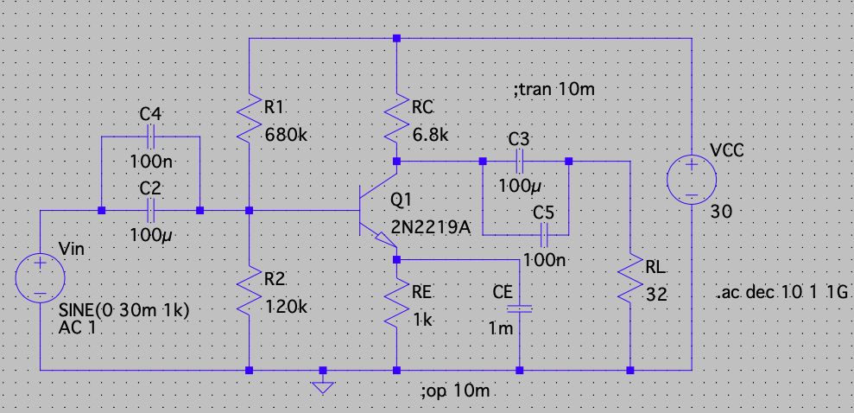

Frequency Response: -

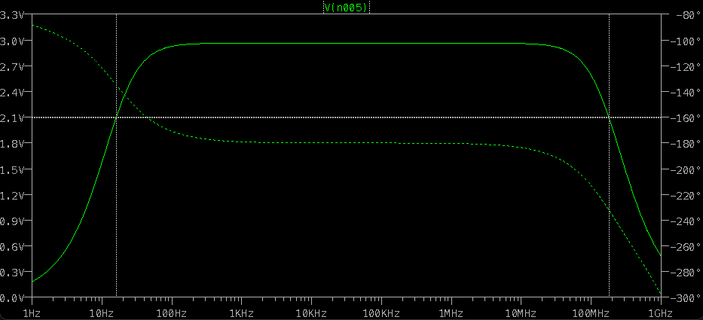

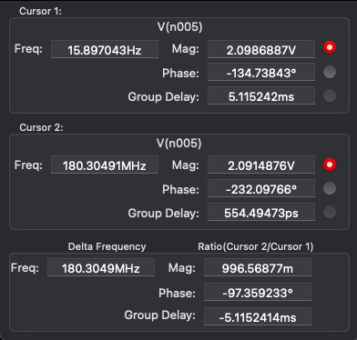

Phase Difference and Maximum Gain in Db: -

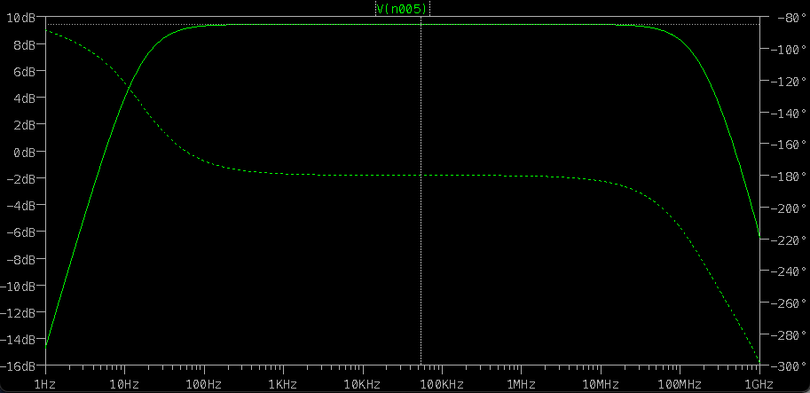

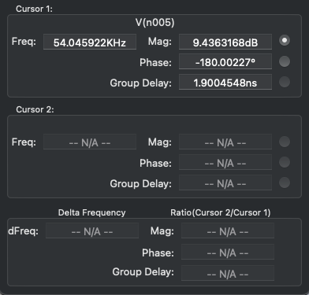

Phase Difference and Maximum Gain in Volts: -

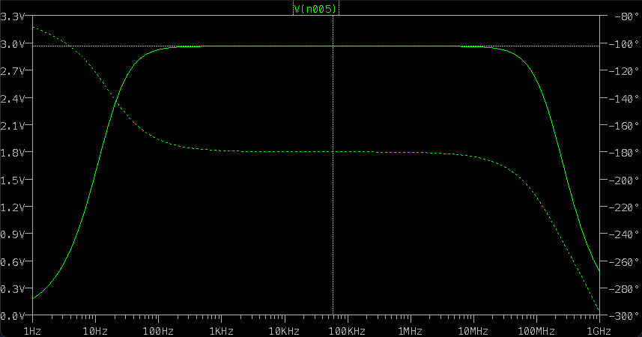

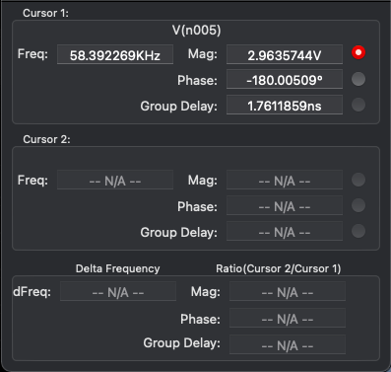

Transient Analysis: -

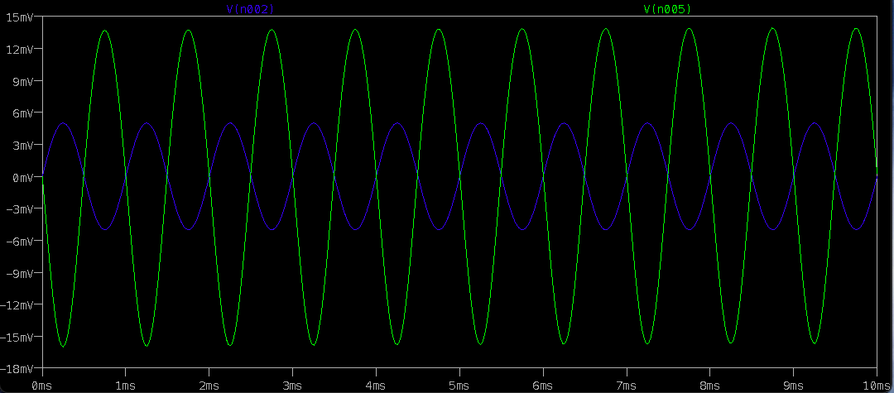

Input Sine Wave: -

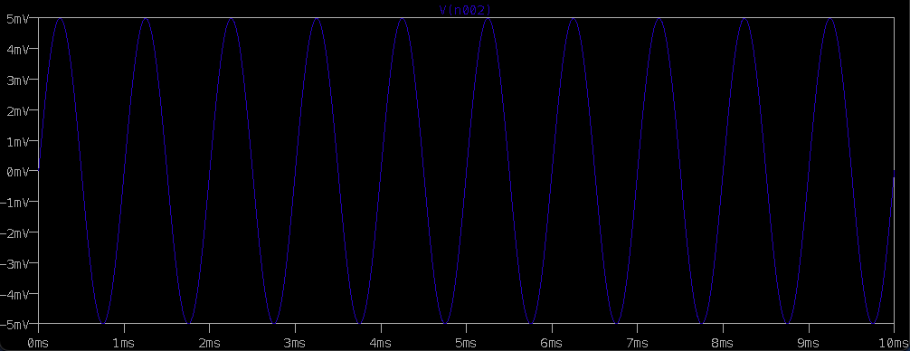

Output Sine Wave: -

Amplified: -

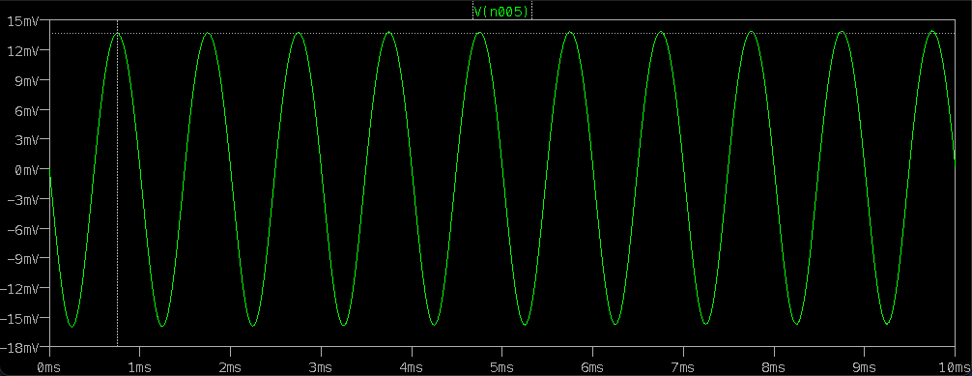

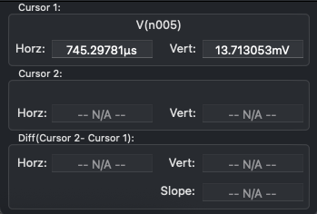

Calculations: -

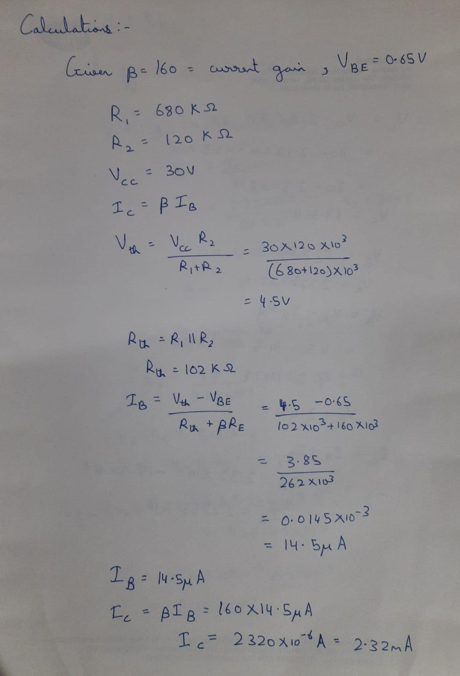

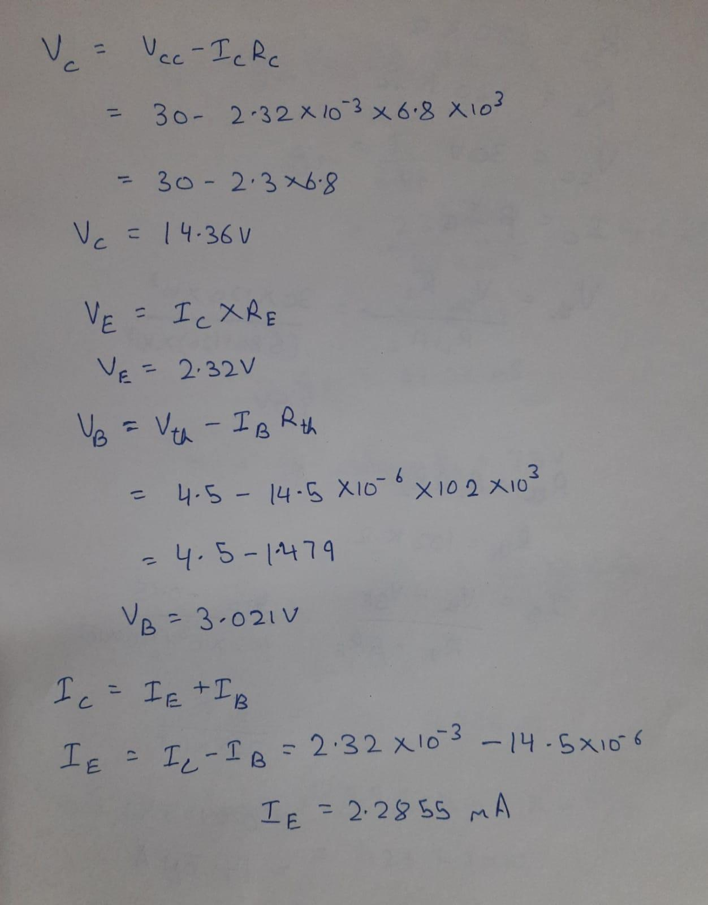

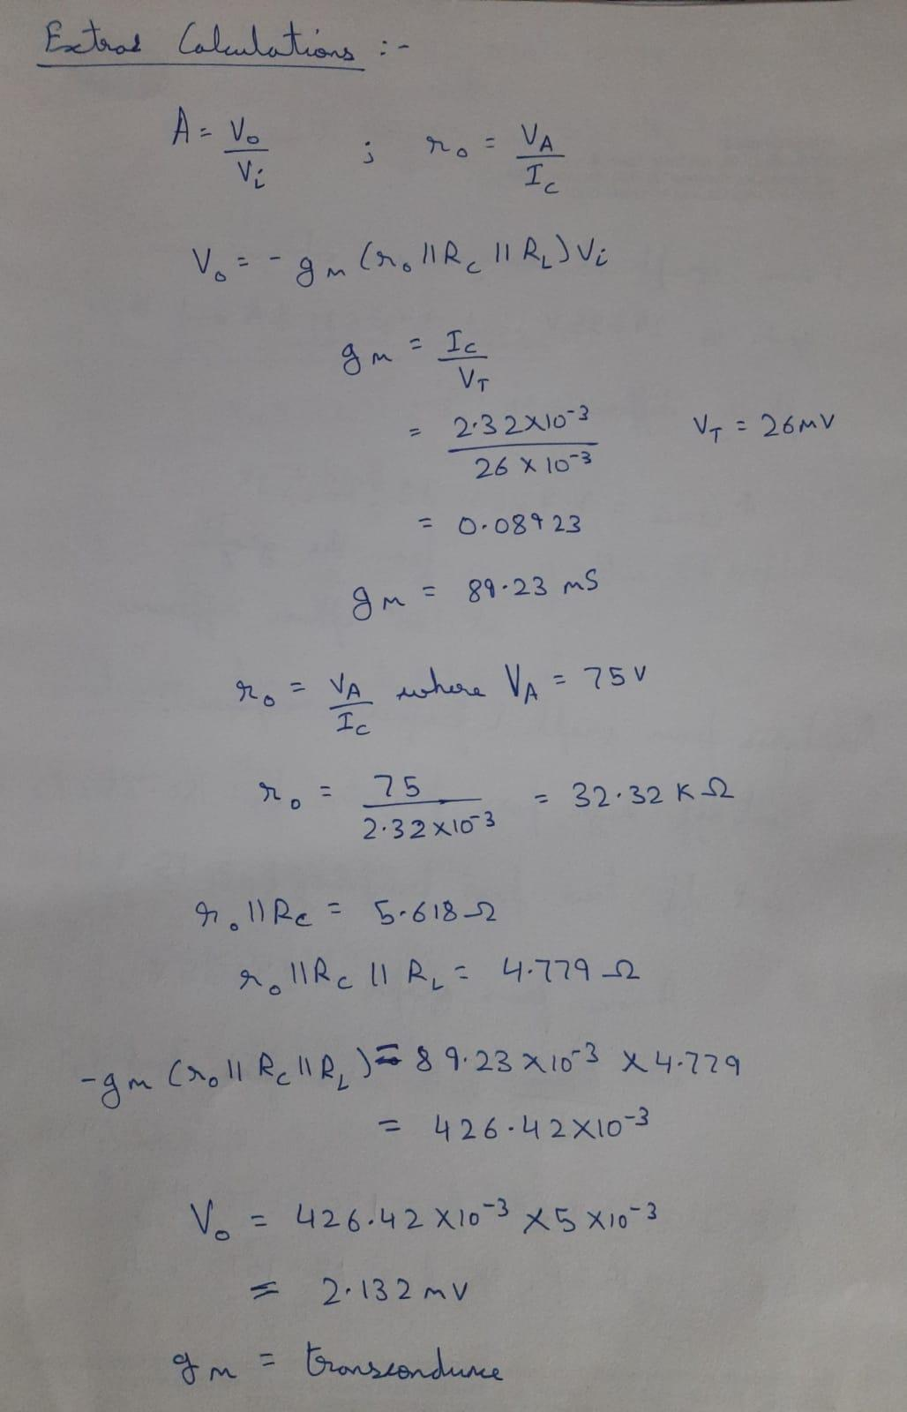

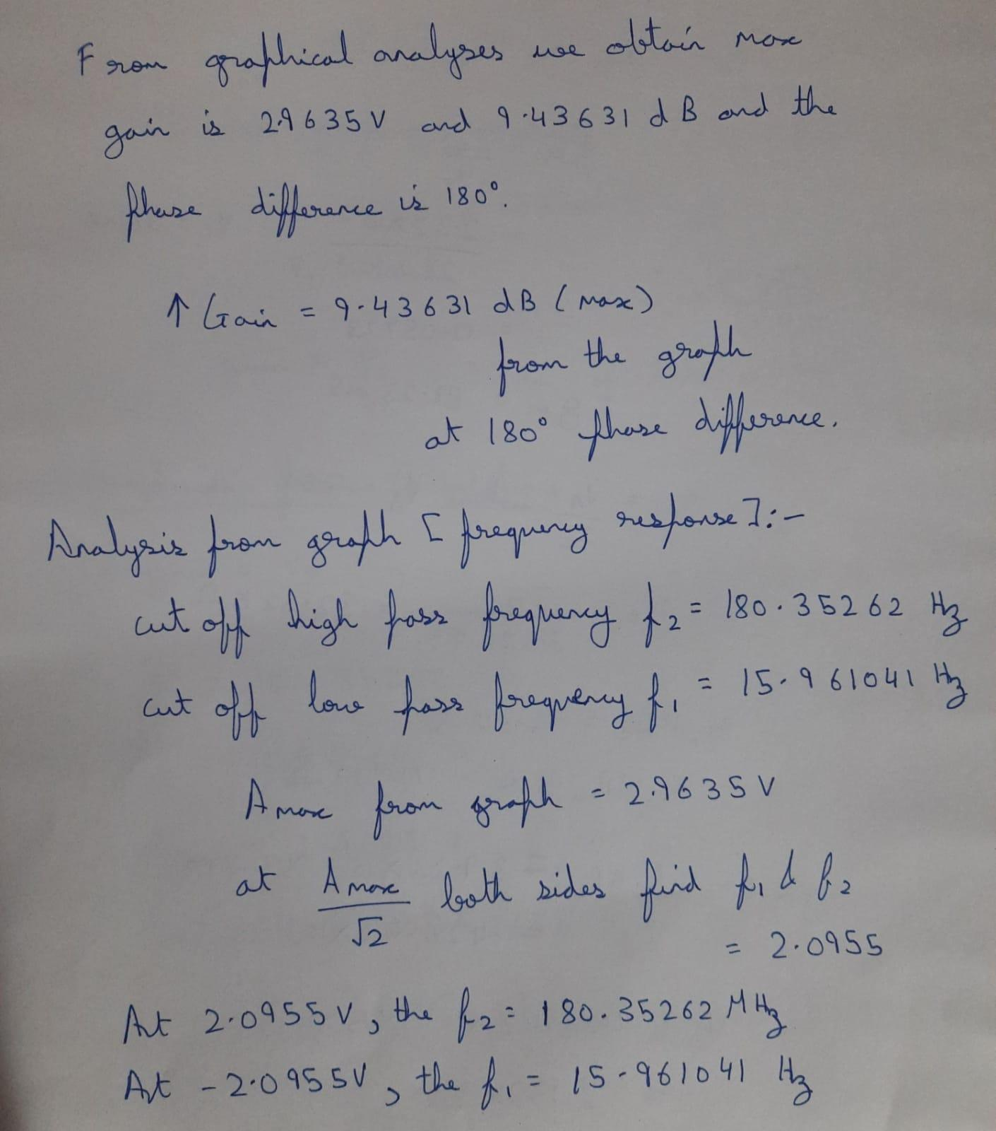

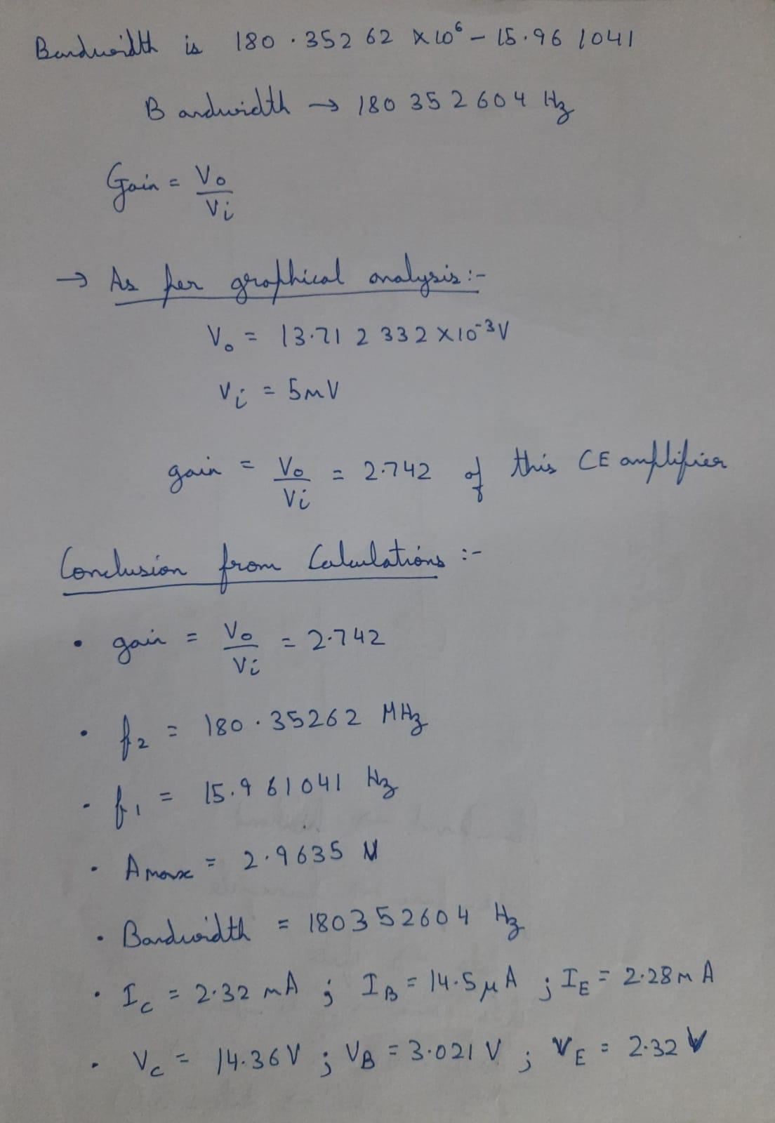

Calculated: -

* GAIN = V0/VI
* F2 = 180.35262 MHz
* F1 = 15.961041 Hz
* Amax = 2.9635 V
* Bandwidth: - 180342604 Hz
* IC = 2.32 mA
* IB = 14.5 µA
* IE = 2.28 mA
* VC = 14.36 V
* VB = 3.021 V
* VC = 2.32 V
* Gm = 426.42 milli.

Result: -

BJT “CE Configuration Amplifier” successfully analysed in LT Spice.